Green Space, Gentrification, and Displacement - DRAFT -
2024

Overview
While the many benefits of urban forestry and green space in urban areas are well-documented, there can be considerable apprehension about new initiatives increasing property values and potentially displacing current and long-time residents. To combat these unwanted outcomes, localities, organizations, and individuals must engage in equitable green development through a variety of policy and community engagement measures. There is a variety of useful research and case studies to help inform best practices to ensure access to green space for all without displacing residents.

Key Considerations from Workshops

- Miscommunication and Knowledge Gap: Pervasive miscommunication and a lack of knowledge affecting community attitudes toward urban forestry.
- Infrastructure Impact: Concerns about potential damage, such as pipes being ruined, if trees are planted too close to homes, with a reluctance to assume financial responsibility for resulting issues.
- Uncertainty about New Projects: Concerns about the nature of "new projects" and their implications for the community, accompanied by a general distrust of government involvement and a desire for inclusion in decision-making processes.
- Historical Letdowns: Past experiences of flawed processes and bad faith engagement have left some communities skeptical about the success and sincerity of new efforts.

Case Studies
The following are selected examples of green space development that has incorporated anti-displacement strategies and tools to promote equitable urban forestry access.
- Dequindre Cut, Ella Fitzgerald Park, & Joe Louis Greenway– Detroit, Michigan: Two greenway and park initiatives in Detroit employed multiple anti-displacement strategies to ensure maximum community benefit. For example, the Joe Louis Greenway, a 27.5 mile stretch that connects downtown Detroit to Dearborn, was routed intentionally over formerly redlined borders of neighborhoods. Extensive community engagement over design and location yielded a “strategic green space.”
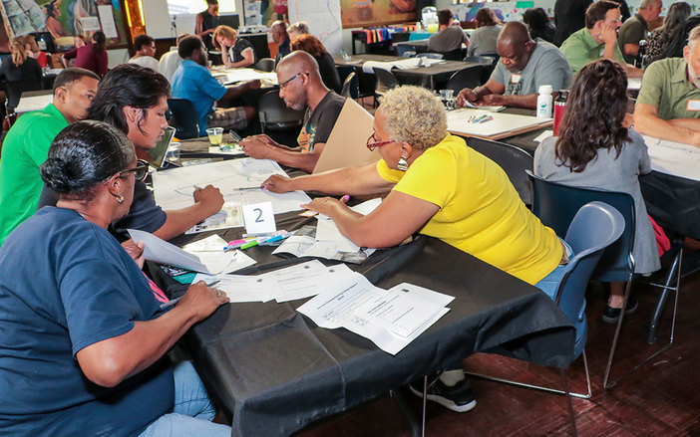
Joe Louis Greenway Community Planning
- Franklin Park – Boston, Massachusetts: The Franklin Park Action Plan, commissioned by the City of Boston, provides a roadmap for reinvestment in Franklin Park, Boston’s largest park. As a part of this reinvestment, thoughtful and extensive community engagement was conducted to limit displacement. Clear anti-displacement goals and lessons learned from green gentrification in other cities like St. Louis and New Orleans, were identified and deemed foundational to any effort to reinvest in the park.

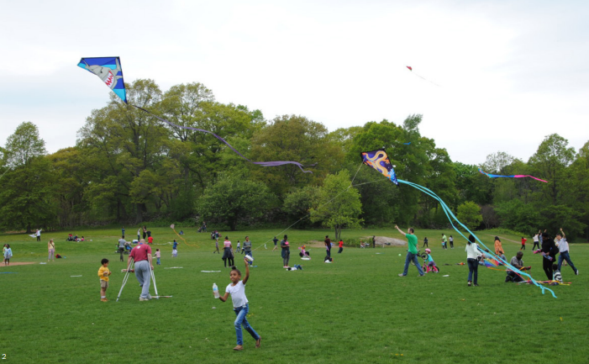
Franklin Park, Boston

- Los Angeles Regional Open Space + Affordable Housing Collaborative (LA ROSAH) – Los Angeles, California: This coalition of organizations from real estate developers, conservation organizations, and community/neighborhood organizations committed to advancing strategies that prevent displacement in communities related to green gentrification. Serving as a networking space, think tank, and convener, this type of coalition can be replicated across the country.

Selected Resources

- Greening without Gentrification: “Parks Related Anti-Displacement Strategies,” or PRADS, developed by Alessandro Rigolon and Jon Christensen, are 26 distinct activities that have been proposed or implemented in 13 projects in 12 cities. This broad range of options that incorporate private developers, nonprofit developers, residents, localities, and other organizations provide a great guide for action to ensure access to green space for all.
- Policy and Planning Tools for Urban Green Justice: This report from the Barcelona Laboratory for Urban Environmental Justice and Sustainability provides descriptions and analysis of over 50 tools and policies to support both housing equity and inclusive green development. There is also a review of current tools employed by localities to prevent gentrification and displacement, and even an analysis of implementation of some of these strategies in both North American and European city contexts.
- Sharing the Benefits of a Greening City: The CREATE Initiative at the University of Minnesota created this toolkit to help individuals, organizations, and localities evaluate gentrification risks and advocate for equitable green space development. A three-part toolkit is also included which introduces key concepts related to green gentrification, describes anti-displacement strategies, and provides information about implementing these strategies.

References

Franklin Park Action Plan. (2022, July 13). Franklin Park Action Plan. https://franklinparkactionplan.com

Greening without Gentrification: Learning from Parks, Related Anti-Displacement Strategies Nationwide; Institute of the Environment and Sustainability at UCLA. (2023, October 16). Institute of the Environment and Sustainability at UCLA. https://www.ioes.ucla.edu/project/prads/

Greening without Gentrification: Learning from Parks, Related Anti-Displacement Strategies Nationwide; Institute of the Environment and Sustainability at UCLA. (2023, October 16). Institute of the Environment and Sustainability at UCLA. https://www.ioes.ucla.edu/project/prads/
Green, J. (2023, December 20). New Green Spaces Don’t Have to Lead to Gentrification. ArchDaily. https://www.archdaily.com/976079/new-green-spaces-dont-have-to-lead-to-gentrification
LA ROSAH | LA ROSAH. (n.d.). https://larosah.org
Oscilowicz, E. (2021, May 12). Policy and Planning Toolkit for Urban Green Justice. Barcelona Lab for Urban Environmental Justice and Sustainability. https://www.bcnuej.org/2021/04/08/policy-and-planning-toolkit-for-urban-green-justice/
Toolkit - CREATE Initiative. (2020, May 25). CREATE Initiative. https://create.umn.edu/toolkit/

