# Branding & Identity

### Program Name Examples

A common program name ensures consistency across materials associated with your initiative, raises visibility, and fosters a clear understanding of your initiative’s goals and purpose.

Here are options related to trees, green spaces, and nature that speak to this initiative’s purpose and goals.

## Leaf It



CitiBloom Grow On

Spreading Roots

*1*

## Neighborwood Nurtures

*Urban & Community Forestry Toolkit: DRAFT*

# Branding & Identity



### Spreading Roots Logos

We have provided primary and two secondary, white & black, versions of the Spreading Roots logo. You can also download different file types based on your needs from the Toolkit landing page including .jpeg, .pdf,

.png, and .svg files.

Only use the black logo when color is a restraint in your design (e.g. a black and white print out).

Use the .pdf or .svg files when possible to ensure maximum resolution.



*Urban & Community Forestry Toolkit: DRAFT*

# Branding & Identity



### Logo Examples

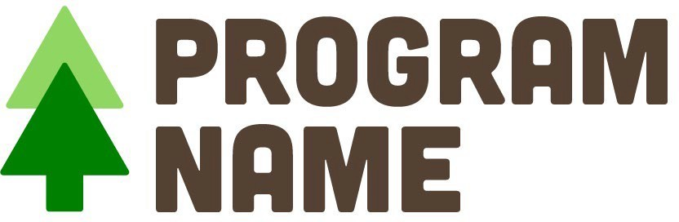Here are a few additional logo considerations. Feel free to use these as as inspiration when designing your logo and brand identity.

Consider how each communicates a different idea, elicits a different emotion, or speaks to a different aspect of urban and community forestry. Be sure to tailor your logo to fit your organization’s needs.

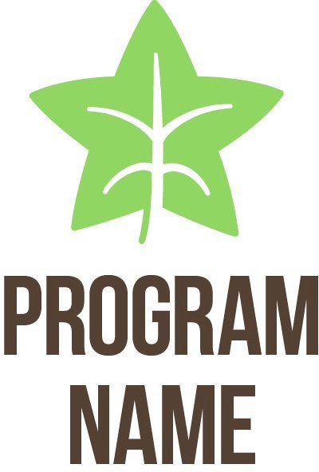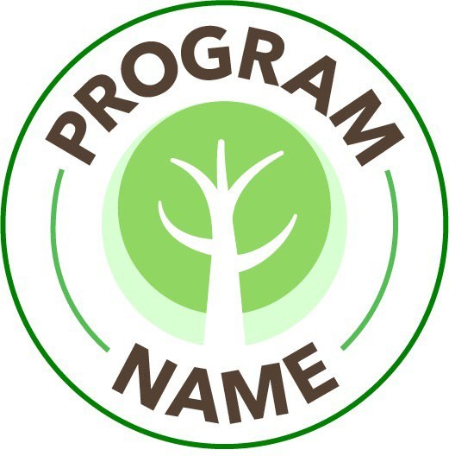

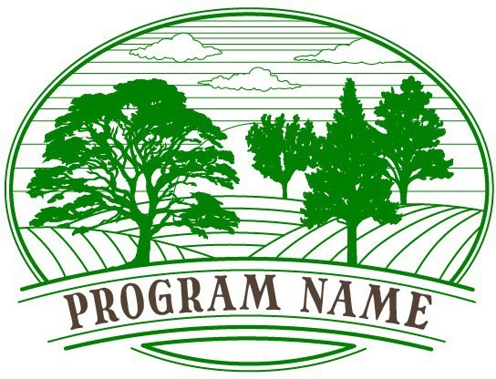

*3*

*Urban & Community Forestry Toolkit: DRAFT*

# Branding & Identity



### Logo Lockup Examples

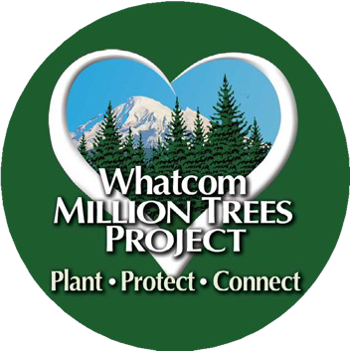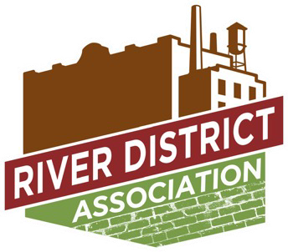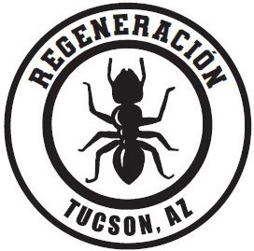A logo lockup combines and presents different elements of a logo in a specific arrangement for various applications. It typically includes the primary logo along with other essential elements like taglines, icons, or secondary graphics. The main purpose is to make a unified and powerful visual statement while promoting a cohesive identity and enhancing brand recall.

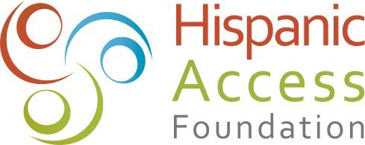Several workshop participants provided their logos for these renderings, demonstrating how they can

successfully pair with the Spreading Roots logo. When creating logo lockups, consider developing vertical and horizontal options to accommodate different design needs.





*4*

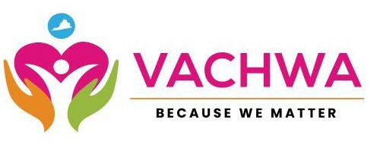

*Urban & Community Forestry Toolkit: DRAFT*