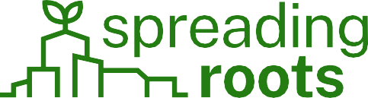

Public Outreach

*Social Media*

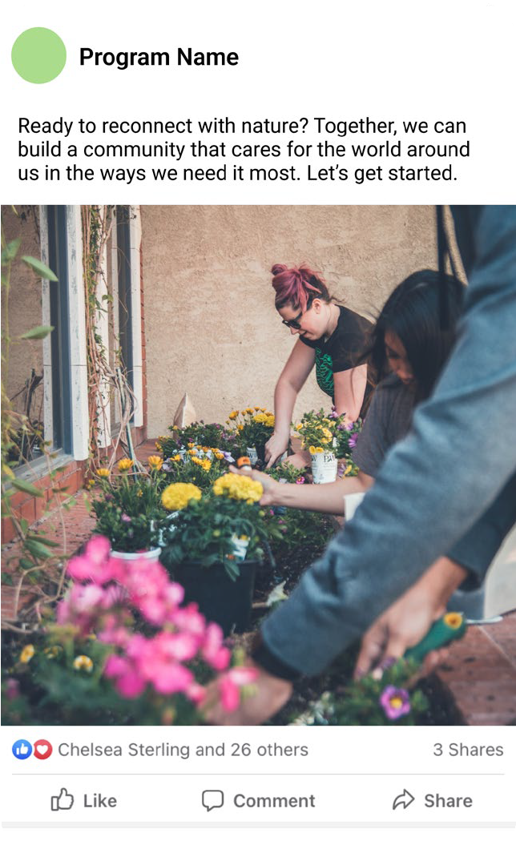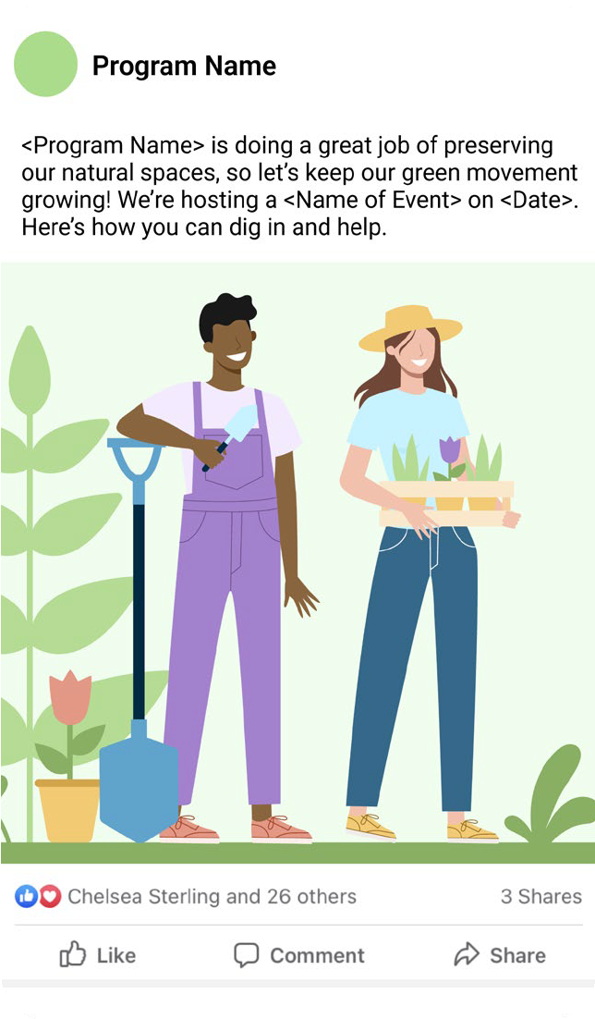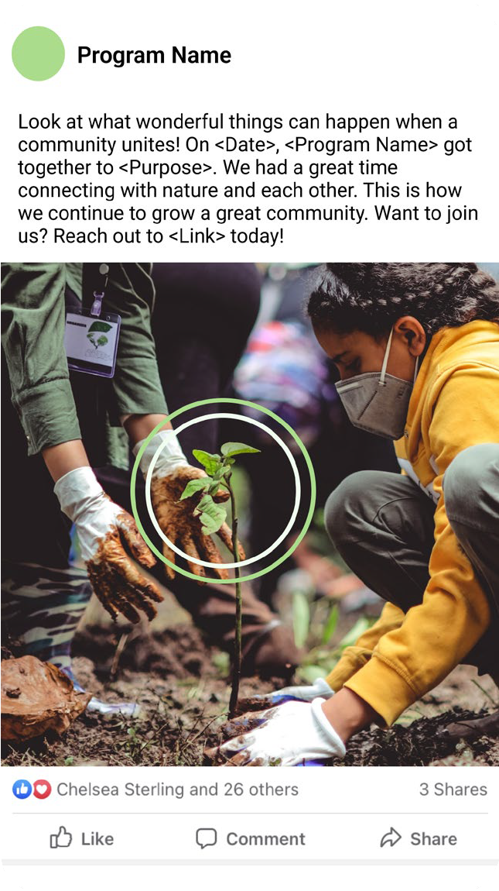Social media posts can be instrumental in advancing an urban and community forestry initiative by leveraging the reach and engagement potential of online platforms. They foster two-way communication by encouraging questions and discussions and can also get your community more involved. Perhaps best of all, social media analytics can help track post reach, engagement, and audience demographics, providing you with valuable insights for refining your initiative’s strategy.

The options shown here promote an organization, participation in an event, and the results of an event. Each uses a different graphic element to see what best connects with audiences.

For best practices, HubSpot provides a handy [Social Media Marketing Guide](https://blog.hubspot.com/marketing/social-media-marketing).