# Branding & Identity

## Program Name Examples

A common program name ensures consistency across materials associated with your initiative, raises visibility, and fosters a clear understanding of your initiative’s goals and purpose.

Here are options related to trees, green spaces, and nature that speak to this initiative’s purpose and goals.

Spreading Roots

Leaf It



CitiBloom Grow On

Neighborwood Nurtures

*Urban & Community Forestry Toolkit: DRAFT* *1*



# Branding & Identity

## Spreading Roots Logos

We have provided primary and two secondary, white & black, versions of the Spreading Roots logo. You can also download different file types based on your needs from the Toolkit landing page including jpeg, pdf, png, and svg files.







# Branding & Identity

## Logo Lockup Examples

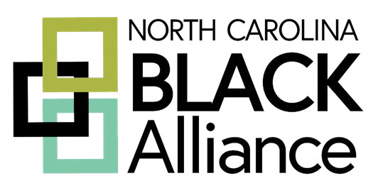A logo lockup combines and presents different elements

of a logo in a specific arrangement for various applications. It typically includes the primary logo along with other essential elements like taglines, icons, or secondary graphics. The main purpose is to make a unified and

powerful visual statement while promoting a cohesive identity and enhancing brand recall.

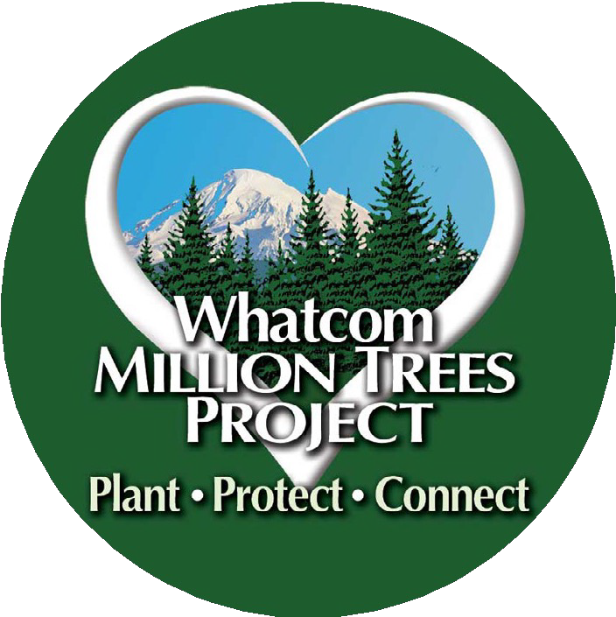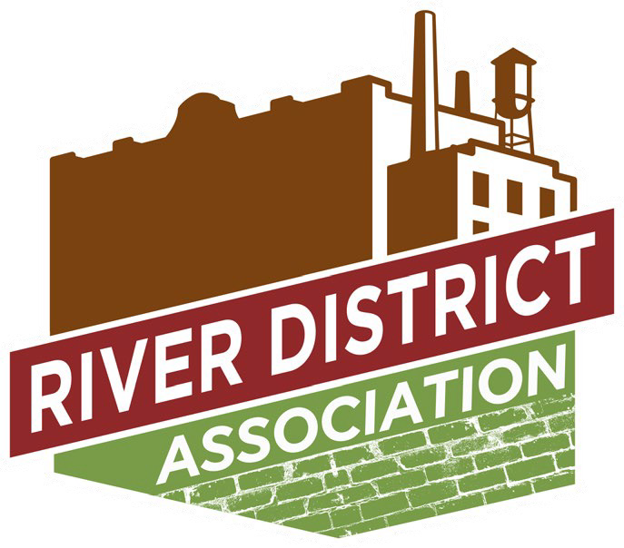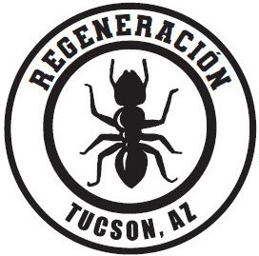Several workshop participants provided their logos for these renderings, demonstrating how they can

successfully pair with the Spreading Roots logo. When creating logo lockups, consider developing vertical and

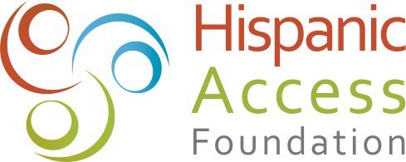horizontal options to accommodate different design needs.



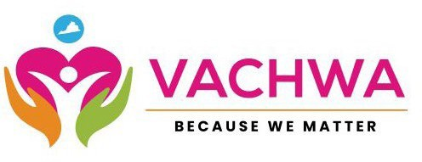

*Urban & Community Forestry Toolkit: DRAFT* *3*