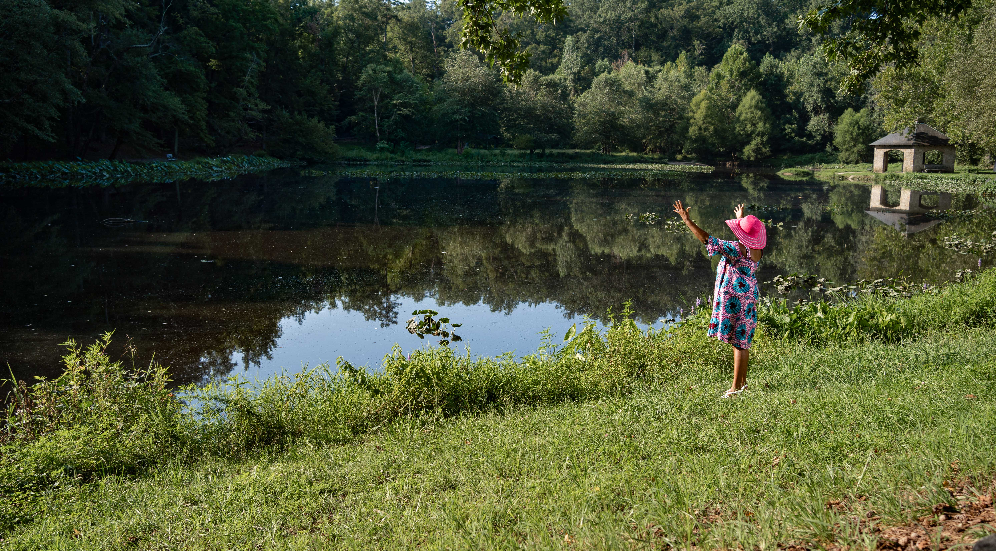

Mental Health Benefits Fact Sheet

- People who live near green spaces are less depressed and have better “thinking” abilities

- Nature helps people recover from stress.

- Trees, Green Spaces and Nature supports abilities to problem-solve, remember things, plan and be creative.

- Plants in the works space help employees have better memories and focus.

- Children with access to nature are more disciplined, less angry and more cooperative with peers.

- Gardens help elderly patient’s mobility and mental well-being.

