Physical Benefits Fact Sheet
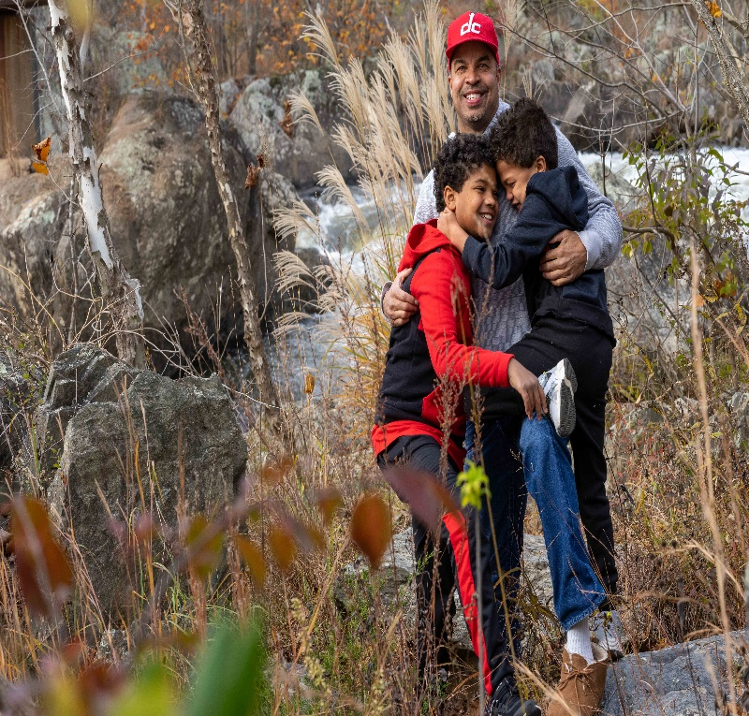 |  | Trees Green Spaces and Nature alleviate stress, stabilize blood pressure and address anxiety and depression in addition to many other benefits.  Benefits  - People Live Longer.  - Adults reduce risk of chronic health conditions including cancers and heart disease/  - Patients have faster Surgical Recovery.  - Pregnant women have less stress and higher birth rates.  - Children of all ages engage in more physical exercise.  - Children playing in nature have better balance, motor skills and coordination.  - Being outside releases endorphins.  - Children have reduced exposure to air pollution, excessive noise and higher temperatures  - Gardens improve quality of life and functions of dementia patients  
